IOT BASED ALERT SYSTEM TO HIGHLIGHT PROCESS FAILED

Business Requirements Document

Votary Softech Solutions Pvt. Ltd.

Plot No: 76, Lumbini layout,  
Near Euro school,  
Gachibowli-I (V), Hyderabad,  
Telangana - 500032,  
India.

**Revision History**

|  |  |  |  |  |  |
| --- | --- | --- | --- | --- | --- |
| Version (x.y) | Date of Revision  (DD-MM - YYYY) | Description of Change | Reason for Change | Affected Sections | Approved By |
| 1.1 | 21-07-2017 | Added Build Success case |  | 2.1  4  5.1 |  |
| 2.0 | 02-08-2017 | Designed for multiple repositories | To improve capability | 1, 1.1, 1.2, 1.4, 2, 5.1.1 |  |
|  |  |  |  |  |  |

**Approval History**

|  |  |  |  |
| --- | --- | --- | --- |
| Version (x.y) | Prepared By | Reviewed By/Date | Approved By/Date |
| 1.0 | Arun Nalam |  |  |
| 2.0 | Ashok Lachanolla |  |  |
|  |  |  |  |

**Contents**

1 Define 4

1.1 Objective 4

1.2 Deliverables 4

1.3 Prerequisites 4

1.4 Assumptions 4

1.5 Limitations 4

1.6 Business Risks 4

1.7 Glossary 4

2 Specify 4

2.1 Scope 4

2.2 Schedule and Milestones 4

2.3 Resources 4

2.4 Cost 4

2.5 Market Analysis 5

2.5.1 Competitor Information 5

2.5.2 Substitutes in Market for Product 5

2.5.3 Targeted Domains 5

3 Architecture 5

3.1 Block Diagram 5

3.2 Internal Interfaces 5

3.3 External Interfaces 5

4 Design 5

4.1 Flowcharts 5

4.2 Development Environment 5

4.3 IP Identified 5

5 Implement 5

5.1 System Requirements 5

5.1.1 <Module based> Functional Requirements 6

5.2 Revenue Realization Plan 6

5.3 User Acceptance Criteria 6

5.4 Quality Plan 6

6 Validate 6

7 Deploy 6

8 Maintain 6

# Define

When ever Developer Pushes New Build to Version Control, Build & Integration tool like Jenkins will detect and build, on build FAIL it sends e-mail to Client(Remote Device) through pre-configured e-mail id

Here client is raspberry pi, which is pre-configured with IMAP e-mail client to read received e-mail’s, upon receiving Build FAIL e-mail from B&I Tool should trigger alarm/flash on screen.

Additionally adding more number of repositories/servers to the project, simultaneously all the repositories are detected by the Jenkins and build. If build fails it should send pre-configured e-mail to the client.

## Objective

- B&I Tool should detect new Check in from one or more version control

- Remote Client Devices should able to receive and read e-mail from B&I Tool of BUILD FAILED

## Deliverables

* Applications which runs on remote clients(ex:-raspberry pi)

## Prerequisites

* Less secured access enable E-mail Account
* Internet Access
* For Alarm need speaker/ to flash on screen need LCD display

## Assumptions

B&I Tool and Remote Clients Should have same e-mail pre-configured

## Limitations

If we get more than one build failure at a time we are able to give one alarm that can be closed by the user. Number of pop- up displayed is depending on the number of build fails which carries the message of corresponding build.

## Business Risks

NA

## Glossary

|  |  |
| --- | --- |
| IMAP | Internet Message Access Protocol |
| E-Mail | Electronic Mail |
| B&I | Build and Integration |
| LCD | Liquid Crystal Display |

# Specify

* B&I Tool should detect check-in from version control tool repositories/other server repositories if there.
* B&I Tool should able to build all the jobs which are modified by the developers.
* B&I Tool should able to send the result of build process to corresponding pre-configured e-mail id’s
* if build fail send FAIL e-mail to remote client which is belong to the corresponding repository.
* if build success send SUCCESS e-mail to remote client and run test scripts, generate report
* Remote Client should be pre-configured with IMAP e-mail client
* Remote Client should able to read recevied e-mail’s from the different jenkins/same jenkins jobs.
* Remote Client should able to trigger alarm/flash message on receiving “SUCCESS” mail (Green pop up)
* Remote Client should able to trigger alarm/flash message on receiving “FAIL” mail (Red pop up), this may have more than one Pop-up depending on the number of repositories build got failed.
* if screen/display available remote client will play alarms with message pop ups on screen until user manually stop.
* if screen/display not available remote client will play alarms for per-defined time i.e 60 seconds.
* If 3-repositories from the different servers/same server build fails 3 pop ups on the screen with job name with alarms until the user stops manually.

# Architecture

## Block Diagram

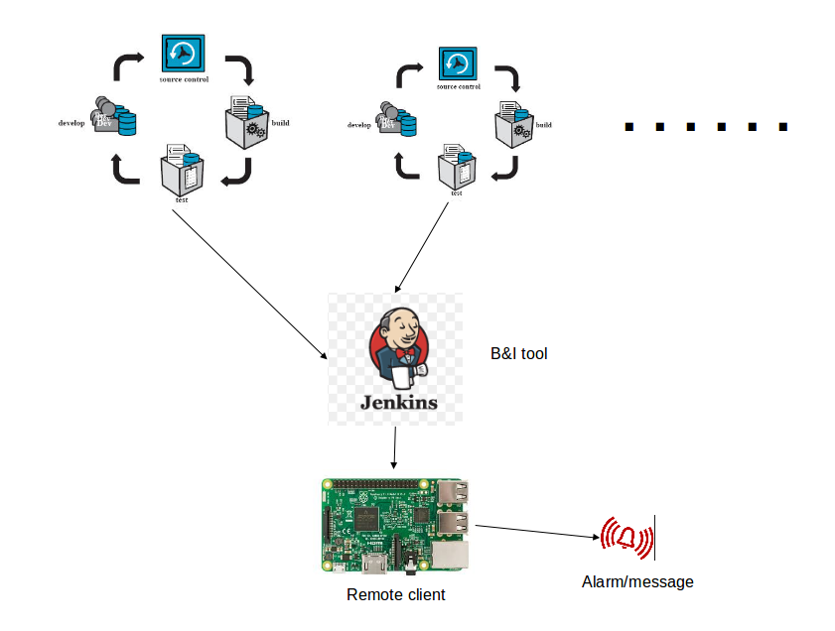

# Design

## Flowcharts

→ Flow Chart for B&I

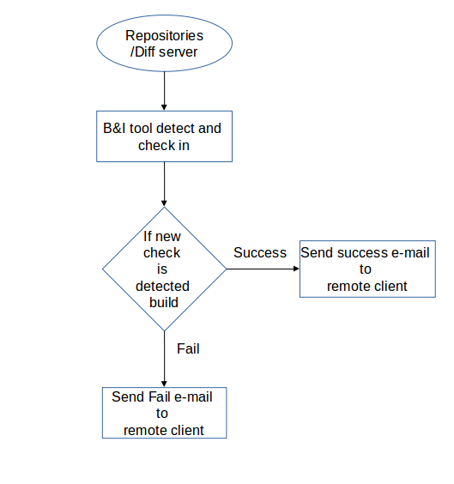

→ Flow Chart for Remote Client

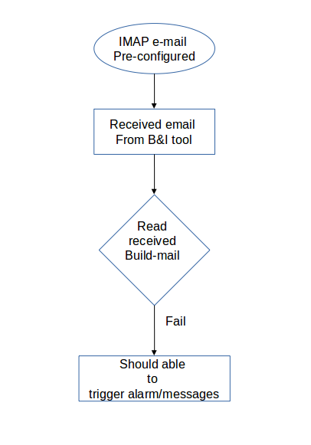

## Development Environment

* Vim Editor
* Python Compiler
* GCC

# Implement

## System Requirements

### Functional Requirements

|  |  |  |  |  |
| --- | --- | --- | --- | --- |
| SL # | Requirements | | | Description |
| 1 | REQ - B&I001 | | | B&I Tool should detect check in’s from version tool |
| 2 | REQ – B&I002 | | | B&I Tool should able to build |
| 3 | REQ – B&I003 | | | B&I Tool should able to send the result of build process to pre-configured e-mail id |
| 4 | REQ – B&I004 | | | if build success send SUCCESS e-mail to remote client and run test scripts, generate report |
| 5 | REQ – B&I005 | | | if build fail send FAIL e-mail to remote client |
| 6 | REQ – B&I006 | | | Remote Client should be pre-configured with IMAP e-mail client |
| 7 | REQ – B&I007 | | | Remote Client should able to read recevied e-mail |
| 8 | REQ – B&I008 | | | Remote Client should able to trigger alarm/flash message on receiving “SUCCESS” mail (Green pop up) |
| 8 | REQ – B&I009 | | | Remote Client should able to trigger alarm/flash message on receiving “FAIL” mail (Red pop up) |
| 9 | REQ – B&I010 | | | if screen/display available remote client will play alarm with message pop up on screen until user manually |
| 10 | | REQ-B&I011 | if screen/display not available remote client will play alarm for per-defined time i.e 60 seconds | |
| 11 | | REQ-B&I012 | Above all requirements should be done for multiple jobs/repositories. | |

## User Acceptance Criteria

B&I tool should able to detect check in’s from version control and build the check in and send build status to remote client, remote client should read e-mail and trigger alarm if “Build FAIL” e-mail is received.